CSCE 462 Final Project Report

Human Following Car System

Rahul Murthy

Andrew Wallace

Ali Javed

**Table of Contents**

**Summary 3**

**Background and Introduction 3**

**Design 4**

**Bill of Material 5**

**Hardware 6**

**Project Logistics 7**

**Request for Reimbursement 7**

**Estimated Technical Work Required 7**

**Work Schedule 7**

**Slack Archive**

**Code 6**

**Needed Tools, and Plan to Acquire the Needed Tools 9**

**Challenges and Solutions**

**Conclusion and Future steps: 12**

**Final Presentation 12**

**Summary**

The project consists of a small motorized vehicle controlled by an Arduino, a cellular phone, and various sensors. The vehicle will follow a person walking a fixed distance in front of it and speed up/slow down as necessary to maintain that distance. The vehicle will stop when the person stops and make turns when the person makes turns. Should the person get too far from the vehicle, or walk in an area where the vehicle has a difficult time following, the vehicle will stop, send an alert via Bluetooth to the person’s cellular device, and make a beeping sound at a fixed interval to help the person locate it.

**Background and Introduction**

When choosing a project topic, we needed to think of something that was doable for a semester long project, but also challenging enough to provide enough complex work for three people. One other important component was that it could be applied to real world scenarios. The reason for this is that in order to make an impressive project we need clear goals that solve a particular problem. In our case, the clear goals would be to design and build an object capable of following a person walking ahead without the person constantly needing to adjust and supervise the object to make sure it stays on course. Also, we want to aid the person and the object in finding each other in the event that the person or object gets lost. Luckily, there are ample resources online on how to do simpler versions of our system, which means we will have plenty of help starting out and getting a basic prototype working before the semester’s end. However, the additional challenge that we’ve added to our project makes it difficult enough to provide each team member with an adequate supply of roles and responsibilities. Lastly, a system that can follow a person walking a fixed distance in front of it, keep up with changes in speed, avoid other objects in the surrounding environment, and make turns with the person would be very useful for something like hauling around luggage in an airport, carrying equipment at a construction site, and any other situation that requires a person to carry things around while also trying to focus on where they are going. All this being said, we decided that the Human Following Arduino Based Car System was the right project for our group.

In the previous paragraph, we explained our reasoning for choosing our project and briefly stated what the system will do at a high level. However, we did not specifically state the “clear goals” that we will be trying to accomplish. For the sake of transparency, those goals are listed as follows:

* Follow a person at a fixed distance, even around turns
* Adjust speed accordingly in response to the person slowing down or speeding up
* Avoid obstacles such as table legs, shelves, and chairs
* Avoid hitting walls, especially when making turns
* If lost, find the person by sending an alert to their phone and making beeping noises

**Design**

The system will consist of 3 abstract components: vehicle, beacon, and retrieval system. Each component has its own subcomponents, which will be explained in more detail below.

***Vehicle***

As mentioned above, the vehicle has its own subcomponents: legs, eyes, and brain. The legs are fairly simple, just 4 small wheels attached to the body of the vehicle via motorized gears that are controlled by the brain of the vehicle. The motorized gears will be connected to the brain via jumper wires and the driver motor shield. The code, which will be stored and run on the brain of the vehicle, will control the speed and direction of the wheels based on the input it receives from the eyes. If the data coming from the eyes indicates that the person is further away from the vehicle than the fixed distance allows for, then the brain will need to increase the speed of the wheels. However, if the data indicates that the person is getting closer to the vehicle than the fixed distance allows for, then the brain will need to decrease the speed of the wheels. Decreasing wheel speed will not only happen if the person gets too close. It will also decrease if the eyes indicate that another object is in the way. We intend to have our system work properly even in an environment where there are multiple obstacles such as shelves, chairs, tables, and walls, so it is critical that we have some sort of collision detection logic in place. Collision avoidance will take precedence over following and/or matching pace with the person and will tell the brain of the car to change the direction of the wheels in addition to their speed. Since the wheels cannot actually turn, we will have to accomplish changes in direction by altering the speed of the front and rear wheels on one side of the vehicle. By having the wheels on one side go slower or faster than the other side, the vehicle should drift to one side for a long enough period of time to avoid the obstacle in front of it. In certain situations, the brain might have to stop the wheels entirely and make a 90 degree turn by having the wheels on one side rotate in the opposite direction (clockwise/counterclockwise) of the wheels on the other side.

The eyes of the vehicle consist of two types of sensors: IR and Ultrasonic. We will have three IR sensors located on the front of the vehicle about 45 degrees apart. One IR sensor will look left, one will look right, and one will look directly forward. We do this to help the vehicle follow the person more accurately, especially when making turns. The IR sensors will be connected to the brain of the vehicle via jumper wires. We will also have three Ultrasonic sensors located on the front of the vehicle facing in the same directions as the IR sensors, but mounted slightly above them. The Ultrasonic sensors will also be connected to the brain of the vehicle via jumper wires. It might seem excessive to have two different types of sensors acting as the eyes of the vehicle, but IR sensors do not reliably detect distance. The actual role of the IR sensors is to find the beacon, which is attached to the person, and guide the vehicle in the right direction.

Ultrasonic sensors help us determine how far away certain objects are, which is critical for collision detection with miscellaneous obstacles and the person. The data from the Ultrasonic sensors will be used by the brain of the vehicle to determine whether or not the wheels need to slow down, speed up, or change direction.

The brain of the vehicle is the Arduino Uno. The Arduino will be mounted on top of the body of the vehicle in the center so that it can reach the sensors and wheels as easily as possible.  All connections between the sensors and the Arduino will be made via jumper wires. The Arduino will handle data coming from the Ultrasonic and IR sensors and use that data to determine the wheel speed and direction.

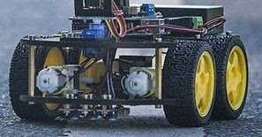

*Figure 1: A sample of what the car system might look like. The IR sensors are not shown on this model.*

***Beacon***

The beacon of the system refers to an anklet worn by the person that emits an IR signal via IR LEDs. This component is what the vehicle will use to track the user’s location, as the vehicle will be fitted with IR sensors that collect the necessary information for tracking. The anklet will be implemented using a Perma-Proto breadboard which allows us to solder the IR LEDs and wires from the power source. The board will be powered by AA batteries and will be fitted on a Velcro strap that can be worn.

***Retrieval System***

In the event that the person (beacon) and vehicle lose each other, we have a retrieval system that will help the person find the vehicle. The retrieval system hardware will consist of a Bluetooth module connected to the brain of the vehicle (i.e. Arduino) and the person’s iPhone. Once the vehicle can no longer see the beacon, it will stop and turn in place 360 degrees to look for the beacon. If it finds the beacon, it will go in the direction of it. If it can’t find the beacon, it will stay put, make a loud beeping sound, and send a notification to the person’s iPhone letting them know that the vehicle is lost.

**Bill of Materials**

|  |  |  |  |
| --- | --- | --- | --- |
| **Part** | **Source** | **Delivery Date** | **Cost** |
| Arduino Uno Rev3 | Arduino Store | October 17 | $45 |
| Motor shield | Proto Supplies | October 22 | $13 |
| Gear motor and wheels | Amazon | October 16 | $16 |
| Servo motor | Adafruit | October 22 | $13 |
| IR Sensors | Amazon | October 17 | $9 |
| IR LEDs | Amazon | October 17 | $6 |
| Battery holder (x2) | Adafruit | October 22 | $14 |
| Jumper wires | Amazon | October 16 | $9 |
| Power switch | Amazon | October 16 | $6 |
| Ultrasonic sensor (x3) | Digi-Key | October 22 | $32 |
| Perma proto board (x3) | Adafruit | October 22 | $19 |
| Bluetooth module | Amazon | October 17 | $10 |
|  |  | **Estimated System Cost:** | **$192** |

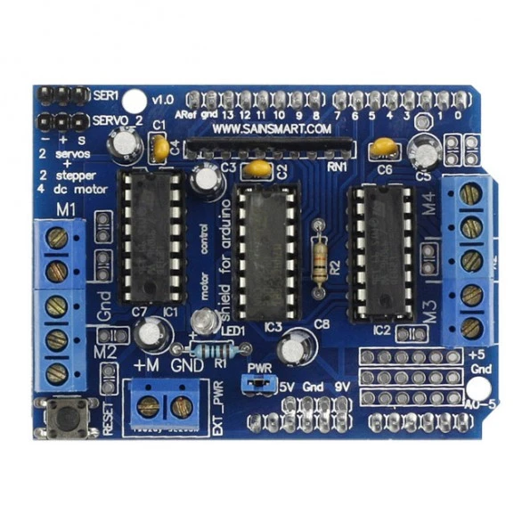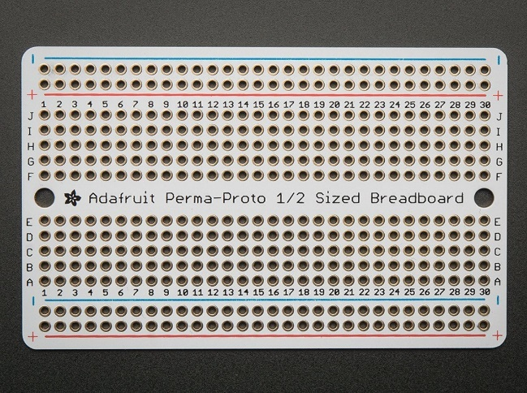

*Figure 2: Arduino Uno motor drive shield & Perma Proto breadboard*

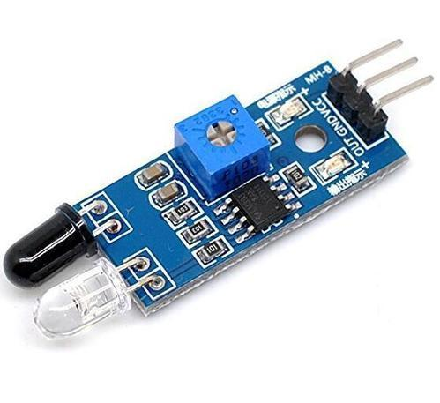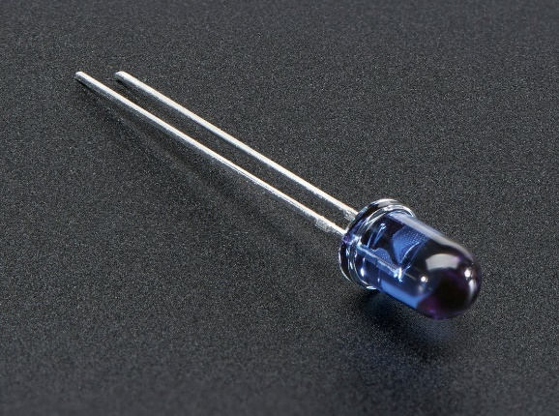

*Figure 3: IR sensor & IR LED*

**Project Logistics**

***Request for Reimbursement***

Due to the need for express shipping options, our system cost is more than what was anticipated. We would appreciate at least a 50% reimbursement to cover these charges.

***Estimated Technical Work Required***

* Manual Work
  + Solder wires to Arduino and sensors
  + Screw the Arduino, sensors, wheels, and motors to vehicle body
* Programming
  + Determine distance from person by measuring the time interval between signals detected by IR sensors
  + Determine turn direction by checking to see which IR sensor detected IR light
  + Tell motors to stop spinning and turn 360 degrees when no light is detected
  + Tell Bluetooth module to signal person’s phone if no IR light signal can be found after spinning 360 degrees
  + Tell Arduino to beep until IR signal is detected again

***Work Schedule***

* Week 1
  + We started thinking about what kind of project we wanted to do
  + We came up with a couple of ideas
    - Building a drone
    - An intrusion detection system
  + We decided on an Arduino based car system that can follow an object
  + Finished and turned in the one-pager
* Week 2
  + Ordered materials and waiting for them to be shipped
  + Working on full proposal
* Week 3
  + Start to the build the car system
  + Run some tests to make sure the car runs properly
* Week 4
  + Finish building the car if there were any unexpected problems
  + Will need to start putting sensors on the car and figure how they work and how they will be integrated into the system
  + Integrate the sensors into the system (IR/Bluetooth)
* Week 5
  + Integrate the sensors into the system (IR/Bluetooth)
  + Deal with any design/coding challenges/errors
  + Start Programming
* Week 6
  + Follow a person at a fixed distance
  + After the car can follow at a distance figure out how it is going to turn and stay with the human
* Week 7
  + If the car is lost, program the car to signal the person’s phone through Bluetooth
  + Beep in intervals till the IR signal is found

***Needed Tools and Plan to Acquire the Needed Tools***

* A Soldering iron and solder
  + We can go to EABA and use the solder and soldering iron
  + Alternatively, Rahul can borrow a soldering kit from a friend
* Hot glue gun
* Acrylic and acrylic cutter
* Cardboard
* Many male to female wires and male to male wires
* Screws and screwdriver to screw the components of the car
  + And hardware store if we don’t already have it